# Web Design Lab 3

## Website Design Evaluation

1. <https://arm.gov>
2. ARM Research Facility
3. The target audience would be climate scientists and government employees.
4. 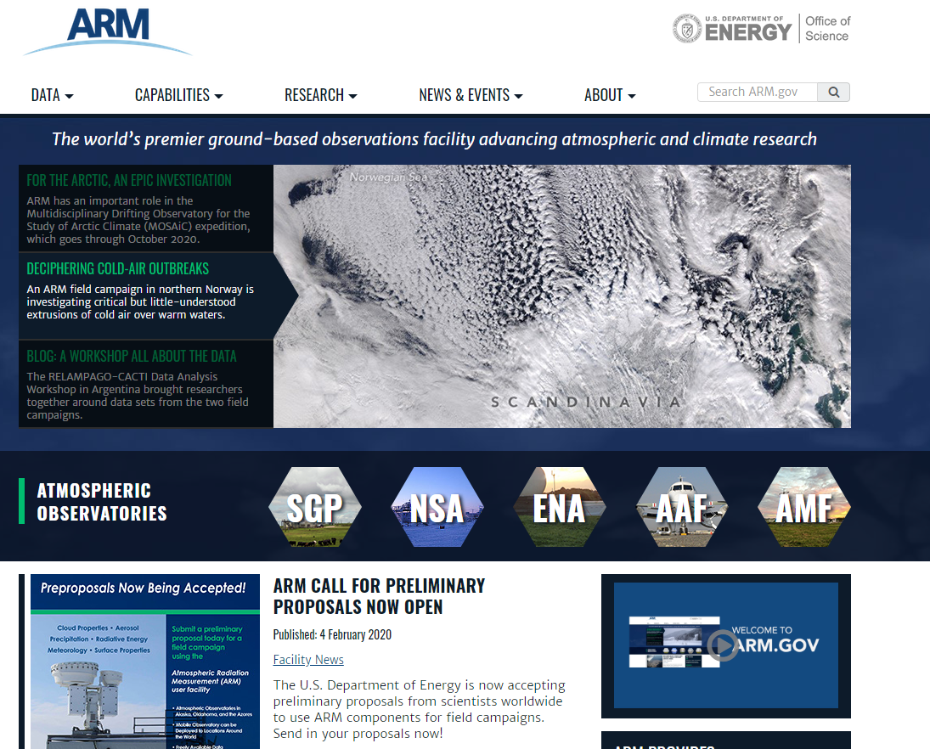
5. This site uses a standard horizontal navigation bar with drop downs, a search box as well as footer links.
6. The utilization of contrast, repetition and proximity are obvious once you scroll down past the hero section at the top of the page as there are consistent square images on the left, followed by a short description of each feature item. These are differentiated from the right hand feature box through the background color contrast. All of these items are aligned with each other providing an easily understandable page and differentiation between the different elemetns.

|  |  |
| --- | --- |
| **Page Layout Criteria** | |
| X | 1. Consistent site header/logo |
| X | 2. Consistent navigation area |
| □ | 3. Informative page title that includes the company/organization/site name  - Page title only includes logo, but the logo includes alt-text so it’s pseudo acceptable. Would like to see a better description of what ARM stands for |
| □ | 4. Page footer area—copyright, last update, contact e-mail address  - No email address or last update. However this is consistent with government websites and frankly the idea of including an email address on the footer of a website just invites spam. I honestly don’t think this is a good practice in 2020 at all. |
| X | 5. Good use of basic design principles: repetition, contrast, proximity, and alignment |
| X | 6. Displays without horizontal scrolling at 1024×768 and higher resolutions |
| X | 7. Balance of text/graphics/white space on page |
| X | 8. Repetitive information (header/logo and navigation) takes up no more than one-fourth to one-third of the browser window at 1024×768 resolution |
| X | 9. Home page has compelling information before scrolling at 1024×768 resolution |
| X | 10. Home page downloads within 10 seconds on dial-up connection  - I don’t have a dial-up connection with which to test...again 2020 |
| □ | 11. Viewport meta tag is used to enhance display on smartphone  - the viewport meta tag is used, but it doesn’t reflow whatsoever |
| □ | 12. Media queries configure responsive page layout for smartphone and tablet display  - Nope, see above |
| **Navigation Criteria** | |
| X | 1. Main navigation links are clearly and consistently labeled |
| X | 2. Navigation is structured within an unordered list |
| X | 3. When the main navigation consists of images and/or multimedia, the page footer area contains plain text hyperlinks (accessibility) |
| □ | 4. Navigational aids, such as site map, skip to content link, or breadcrumbs, are used  - No, and being that this is a .gov site that means this site is actually in violation of the ADA and Section 508 (I’m a stickler as that’s my job, it’s also worth noting that there’s not an *Accessibility* link at the bottom of the page which is a general design requirement of .gov sites per Section 508) |
| **Color and Graphics Criteria** | |
| X | 1. Use of different colors is limited to a maximum of three or four plus neutrals |
| X | 2. Color is used consistently |
| X | 3. Background and text colors have good contrast |
| X | 4. Color is not used alone to convey meaning (accessibility) |
| X | 5. Use of color and graphics enhances rather than distracts from the site |
| X | 6. Graphics are optimized and do not slow download significantly |
| X | 7. Each graphic used serves a clear purpose |
| X | 8. Image tags use the alt attribute to configure alternate text (accessibility) |
| X | 9. Animated images do not distract from the site and do not loop endlessly |
| **Multimedia Criteria** | |
| X | 1. Each audio/video/flash file used serves a clear purpose |
| X | 2. The audio/video/flash files used enhance rather than distract from the site |
| X | 3. Captions or transcripts are provided for each audio or video file used (accessibility) |
|  | 4. Download times for audio or video files are indicated |
| **Content Presentation Criteria** | |
| X | 1. Common fonts such as Arial or Times New Roman are used |
| X | 2. Techniques of writing for the Web are applied: headings, subheadings, bulleted lists, short sentences in brief paragraphs, use of white space |
| X | 3. Fonts, font sizes, and font colors are consistently used |
| X | 4. Content provides meaningful, useful information |
| X | 5. Content is organized in a consistent manner |
| X | 6. Information is easy to find (minimal clicks) |
| X | 7. Timeliness: The date of the last revision and/or copyright date is accurate |
| X | 8. Content is free of typographical and grammatical errors |
| □ | 9. Avoids the use of “Click here” when writing text for hyperlinks  - Uses “Read More” but that’s after a short description of the content. I’m actually curious as to if that’s acceptable. |
| X | 10. Hyperlinks use a consistent set of colors to indicate visited/nonvisited status |
| X | 11. Alternate text equivalent of content is provided for graphics and media (accessibility) |
| **Functionality Criteria** | |
| X | 1. All internal hyperlinks work |
| X | 2. All external hyperlinks work |
| X | 3. All forms function as expected |
| X | 4. No error messages are generated by the pages |
| **Additional Accessibility Criteria** | |
| X | 1. Use attributes designed to improve accessibility such as alt and title where appropriate |
| X | 2. The html element's lang attribute indicates the spoken language of the page |
| **Browser Compatibility Criteria** | |
| X | 1. Displays on current versions of Edge, Internet Explorer, Firefox, Safari, Chrome, and Opera |
| □ | 2. Displays on popular mobile devices (including tablets and smartphones)  - No reflow at all. It isn’t unusable on a phone but it would benefit from a mobile version. |

1. Most of my recommendations could be found in the list above but the top 3 would be:  
   1.) Build a mobile version, or at least resize the page for mobile.  
   2.) Make it Section 508 Compliant (add a site map and accessibility link to the footer and utilize “Skip to Content”  
   3.)Better text based logo as opposed to the abbreviation image used.

## Responsive Web Design

1. <https://monese.com/>
2. Monese
3. Young Adults who would like to start an online bank account.
4. Desktop:  
   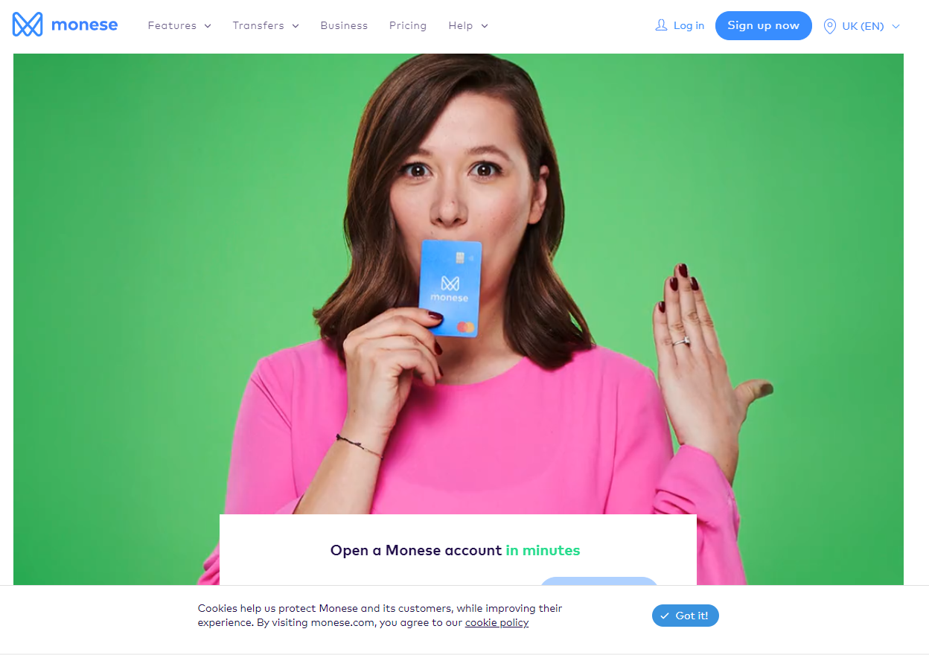  
     
   Tablet:  
   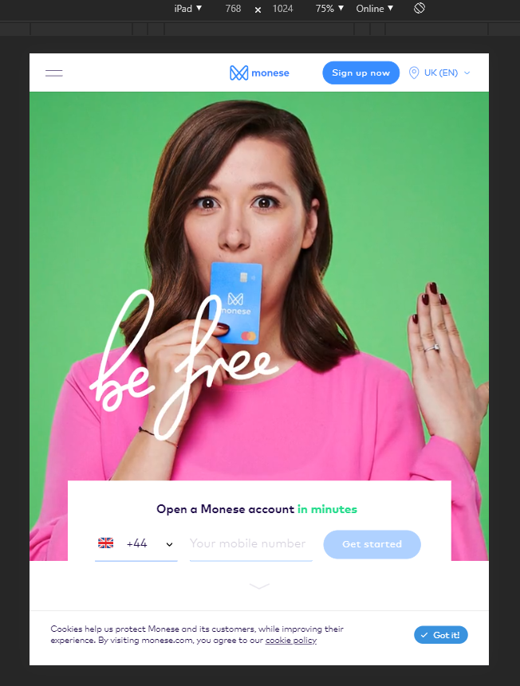  
     
   Smartphone:  
   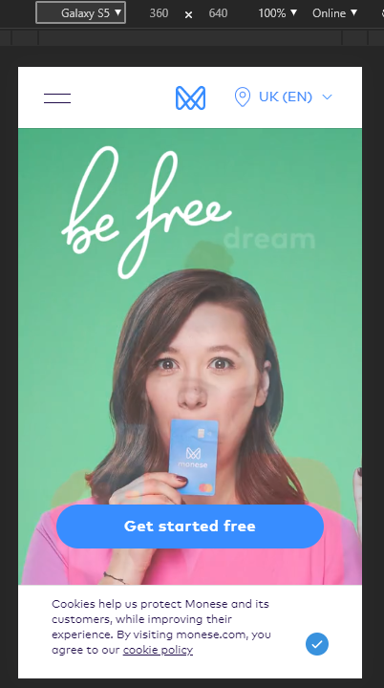
5. All layouts use the same content.  
   All layouts use a large hero image carousel to give the user a “fun” experience and feel.
6. The Desktop and Tablet layouts are very similar, both keeping the right aligned content the same in the navigation bar. However for the smartphone and tablet layout the navigation is compressed into a hamburger slide out menu. Furthermore, in the smartphone layout the “Open an Account” call to action input box is simplified into a single button.
7. The website meets the needs of the target audience in all three display modes. It’s clear that the primary purpose of this page is to entice new customers though, while giving existing customers who are already familiar with the site an easy path to login to their account and handle whatever business they visited the site to accomplish.

## Wireframe Design

